Ideation Phase
Brainstorm & Idea Prioritization Template

Date | 31 July 2026
Team ID | Vemuri Gayathri
Project Name | Metro Ticket Generation System
Maximum Marks | 4 Marks

Step-1: Team Gathering, Collaboration and Select the Problem Statement
1. Goal & Objectives
- Goal: Digitize metro ticket booking using ServiceNow for fast, accessible, and automated ticket generation via QR codes.
- Objectives:
  - Enhance Commuter Convenience: Provide digital booking options (mobile apps, QR codes, WhatsApp) to cut wait times.
  - Increase Operational Efficiency: Implement Automated Fare Collection (AFC) systems to lower manual errors and operational costs.
  - Promote Cashless Adoption: Support digital payment channels (UPI, credit/debit cards, mobile wallets).
  - Facilitate Data-Driven Decisions: Leverage ServiceNow reporting and analytics on peak usage times and passenger behavior.
  - Support Sustainability: Eliminate paper tickets to promote eco-friendly practices.
2. How Might We (HMW) Problem Statement
"How might we digitize and automate the metro ticketing process using ServiceNow so that commuters can seamlessly book QR-code tickets via preferred digital channels while reducing station congestion and operational costs?"

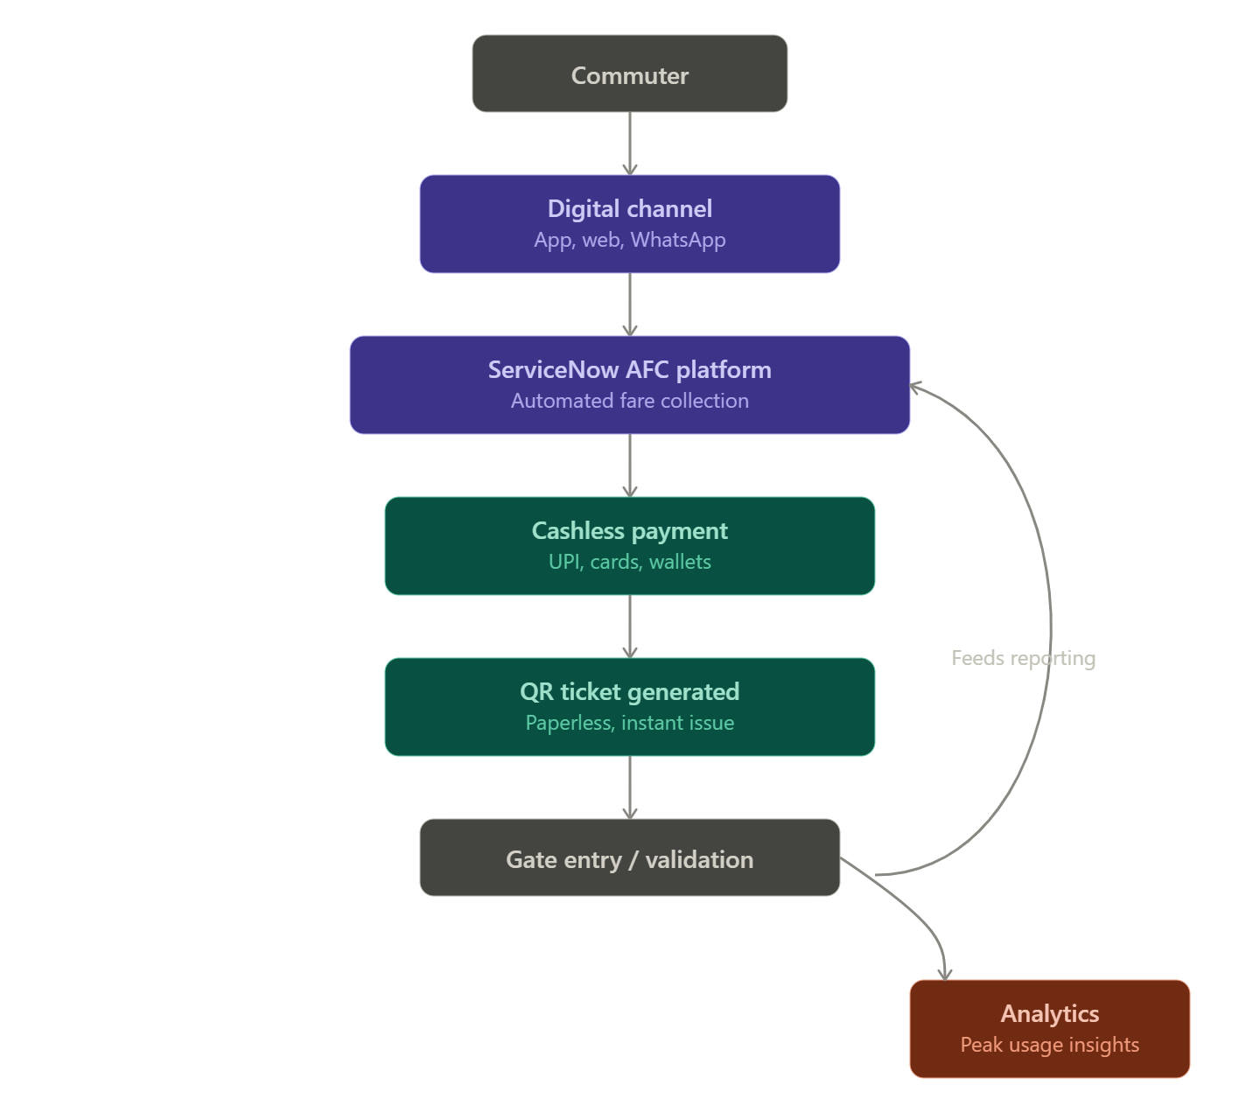

Step-2: Brainstorm, Idea Listing and Grouping
Idea Category 1: Ticketing & Interface Capabilities
- Idea A1: WhatsApp-based ticket booking workflow connected to ServiceNow catalog items.
- Idea A2: Instant dynamic QR code generation sent directly to commuter mobile devices upon ticket confirmation.
- Idea A3: ServiceNow Service Portal / Mobile App interface for rapid single and return ticket purchases.
Idea Category 2: Fare Collection & Payment Integration
- Idea B1: Integration with multi-modal payment gateways (UPI, Credit/Debit Cards, Mobile Wallets).
- Idea B2: Automated Fare Collection (AFC) gate verification via real-time QR code scanners tied to ServiceNow record updates.
- Idea B3: Auto-refund and cancellation workflows managed automatically through ServiceNow Service Portal.
Idea Category 3: Analytics & Sustainability
- Idea C1: ServiceNow Performance Analytics dashboards to track peak traffic, station throughput, and daily revenue.
- Idea C2: Complete paperless transition tracking to measure environmental impact and carbon footprint reduction.

Step-3: Idea Prioritization
Idea Description | Importance | Feasibility | Priority Level
ServiceNow Mobile/Portal Ticket Request & Instant QR Code Generation | High | High | Top Priority (Do First)
UPI & Digital Wallet Payment Gateway Integration | High | High | Top Priority (Do First)
WhatsApp-based Interactive Ticketing Bot via ServiceNow Integrations | High | Medium | High Priority (Phase 2)
Real-time Automated Fare Collection (AFC) Gate Scanner Integration | High | Medium | High Priority (Phase 2)
ServiceNow Performance Analytics Dashboard for Peak-time Route Insights | Medium | High | Medium Priority (Quick Win)
Automated Paperless Sustainability Tracking Reports | Low | High | Low Priority (Nice to Have)

